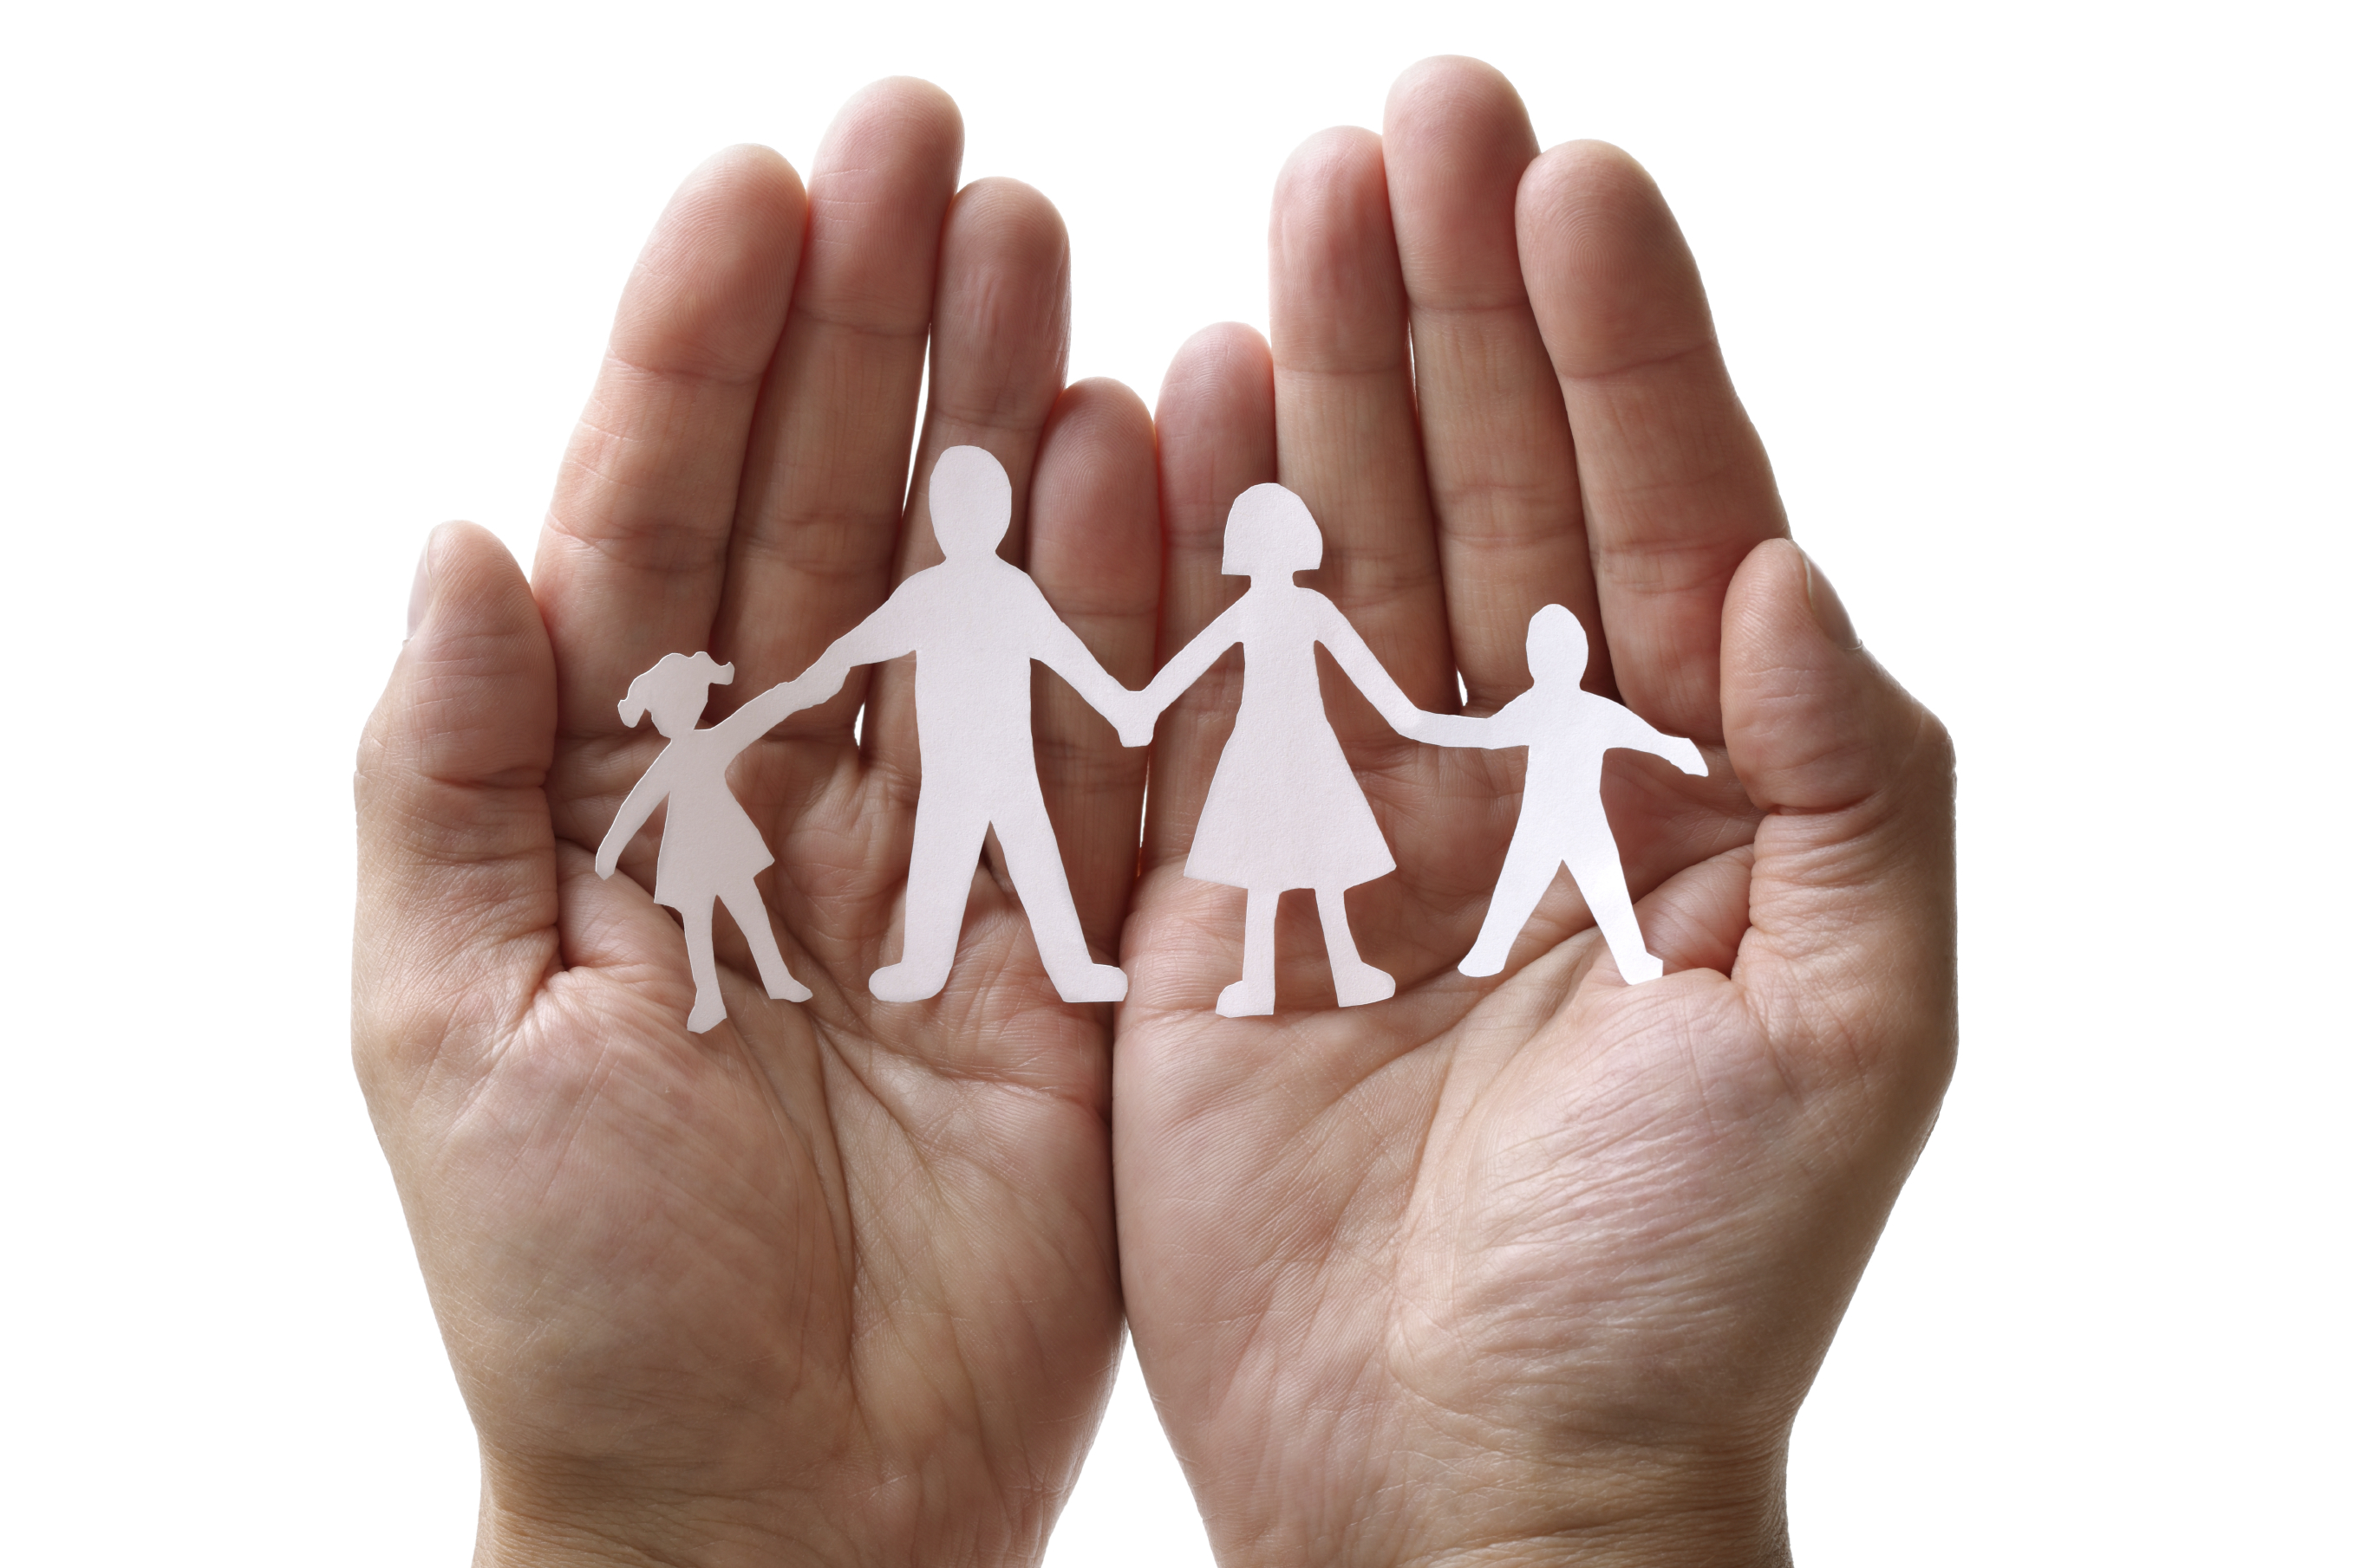
Family-to-Family Communities Project (F2FC)
Connecting Families of Individuals with Deaf-Blindness via Distance Technology
F2FC Registration is now open until August 15, 2020!
https://tinyurl.com/F2FC2020

Questions? Contact Carol Darrah cdarrah@uga.edu or your state deaf-blind project
“I love knowing that there are others like me! It’s wonderful to not to feel
so isolated” (parent)

F2FC brings families together to connect, share information and resources, and offer support to one another in the journey of supporting their family member with deaf-blindness.
Each F2FC is comprised of 8-10 family members; is guided by trained Facilitators; meets once per month for 90 minutes via video-conference or phone; topics are chosen by the group and include structured conversation and open sharing. Your regular participation is vital to the group!

2020-2021 Family-to-Family Communities (adjust for time zones) descriptions include sample topics
Facilitators will contact participants in August; monthly meetings will be Sept 2020 – May 2021
- Love, Laughter, & Mindfulness: 1st Thursday/month at 8:30pm ET; boundaries, self-care, and ways to thrive in life while also caring for your children with deaf-blindness; Facilitators- Heather Joy Magdelano & Donia Shirley
- Communication & Other Hot Topics: 2nd Wednesday/month at 8pm ET; communication for your child, family, and educational team; open discussion about other relevant topics; Facilitators- Jackie Dalzell & Jenn Henkle
- Families with Members who have Peroxisomal Disorders: 3rd Monday/month at 8:30pm ET; communication, educational support, & life balance / self-care; Facilitators- Krista Olsen & Katie Sacra
- Families with Members who have Usher syndrome: 4th Thursday/month at 8:30pm ET; supports, working with your education team, health and wellness, family life; Facilitators- Pam Aasen, Carly Fredericks, & Lane McKittrick
- Families with Members who have CHARGE: 1st Monday/month at 9pm ET; unique needs and services, building a network of support, family dynamics, planning for the future; Facilitators- Djenne Morris & Lori Beth Smith
- Families with Young Children (B-8yrs): 2nd Monday/month at 8:30pm ET; positive social-emotional dev., putting supports in place for your child and family, transition to school; Facilitators- Hannah Fecher & Courtney-Ke Williams
- Life Support: 2nd Tuesday/month at 6:30pm ET; share life’s ups and downs with people who understand- empowering parents from struggles to snuggles; Facilitators- Diane Foster & Katrina Michel
- Adult Life (age 22+): Last Wednesday/month at 7pm ET; adult service systems, employment, housing, life skills, and social relationships; Facilitators- Patti McGowan & Sheri Stanger
- Families with Children who have Complex Needs: 2nd Thursday/month at 7:30pm ET; health care, support providers, educational services, waivers, balancing family life; Facilitators- Nancy Stuart, Jenny Stuhmer, & Bridget Wildschuetz
- Advocacy for your Child and Family: 3rd Tuesday/month at 7pm ET; finding and using your voice to advocate for the unique needs of your child and family ; Facilitators- Brandi Hitzelberger & Chelsea Winchester
- Supporting Academic Rigor: 2nd Tuesday/month at 8:30 ET; supporting your student in the general curriculum, self-advocacy, extracurricular activities, friends, and family life; Facilitators- Nilam Agrawal & Jill Bradshaw
- 258 Chat: 1st Thursday/month at 8pm ET; “very interesting” chat, Deaf-Blind culture, community connections, communication, and advocacy; Facilitators- Valerie Nordstrom & Heather Withrow (meetings will be in ASL)
- Extended Family Members: Fourth Wednesday/month at 7:30ET; for grandparents and other extended family who want to support their loved ones who have a child with deaf-blindness; Facilitator- Jana Villemez
- Spanish-speaking Families: 2nd Thursday/month at 12pm ET; education, relationships, self-care, and leadership; Facilitators- Josefina Gonzales & Doris Tellado; registration for this group ONLY https://tinyurl.com/F2FC2020sp

